# Objective

This example demonstrates how to develop a low power BLE system by using different low power modes of PSoC 4 BLE device and the BLE block. It has various firmware configuration options to measure the overall system power at different device and BLE block configurations and acts as a toolbox to debug low power problems in your design.

This example could be used as a template on top of which you could develop your low power BLE designs.

|  |
| --- |
|  |

# Overview

In this example the BLE Component configured as a GAP Peripheral and a GATT Heart Rate Server is used for measuring PSoC 4 BLE device power primarily at BLE connection interval of 1 second (and can easily be modified for other connection intervals as well). Apart from being a reference firmware for measuring BLE connection interval power consumption, this example also provides firmware configuration options to:

1. Measure PSoC 4 BLE device DeepSleep current
2. Measure PSoC 4 BLE device Sleep current at different operating frequencies
3. Show the amount time for which the device is in Sleep and DeepSleep modes during a BLE connection event by toggling GPIOs
4. Know when the BLE RF interface is in Tx and Rx mode by toggling GPIOs

Refer to [AN92584](http://www.cypress.com/go/an92584) for a detailed description of PSoC 4 BLE power modes, current consumption details and battery life estimator tool

# Requirements

**Design Tool:** [PSoC Creator 3.1](http://www.cypress.com/PSoCCreator/) SP1 with built-in GCC 4.8.4, [CySmart 1.0](http://www.cypress.com/cysmart/)

**Associated Devices & Hardware:** All PSoC 4 BLE devices & [CY8CKIT-042-BLE Bluetooth® Low Energy (BLE) Pioneer Kit](http://www.cypress.com/cy8ckit-042-ble/)

# PSoC Creator Schematic



# Hardware Setup

# BLE Pioneer Baseboard programmed with this example acts as a BLE Peripheral and the BLE Dongle acts as the BLE Central. Connect a multimeter across terminals of jumper J15 on BLE Pioneer Baseboard to measure the current consumed by PSoC 4 BLE device alone (see below). Use BLE Dongle in conjunction with CySmart tool to setup the BLE link for required connection interval or an iOS/Android app if you like to measure the power for 1 second BLE connection interval.

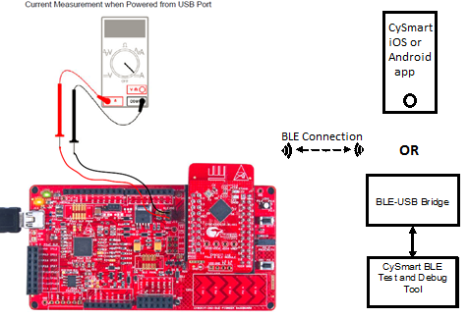

# Firmware:

BLE Component configured as a GAP Peripheral and a GATT Heart Rate Server is used as a base firmware to demonstrate power consumption. The firmware is modular and can be used as a starting point for developing BLE end applications using PSoC 4 BLE device.

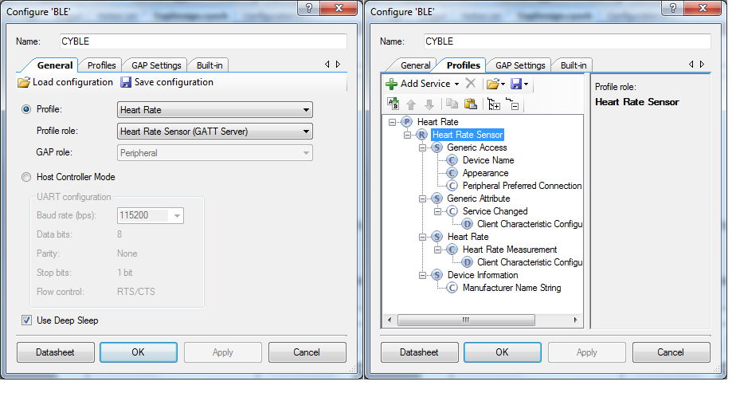

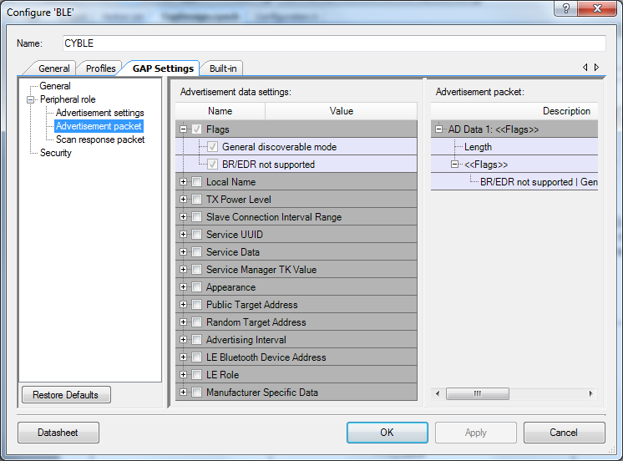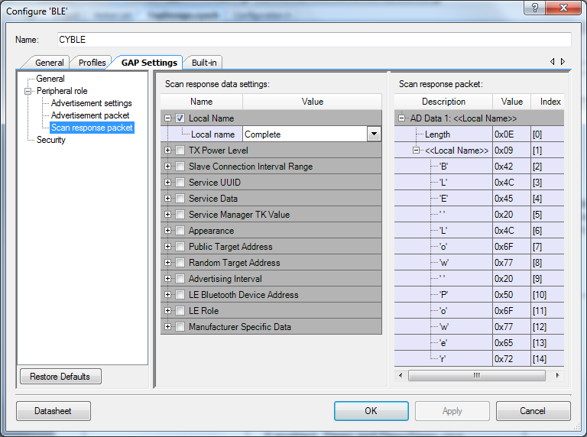

The folder structure of the source code and a brief description of each of the source files are shown below:

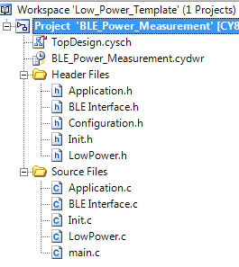

Template application file where you could add your application code

BLE event handler, connection manager and low power source code

System initialization source code

PSoC 4 BLE device low power mode configuration source code

Main entry point source code for the example project

The firmware provides multiple configuration flags to test and debug different device power modes and their corresponding current consumption. All the firmware configuration flags are located in Configuration.h file and a short description of each of the configuration flags are:

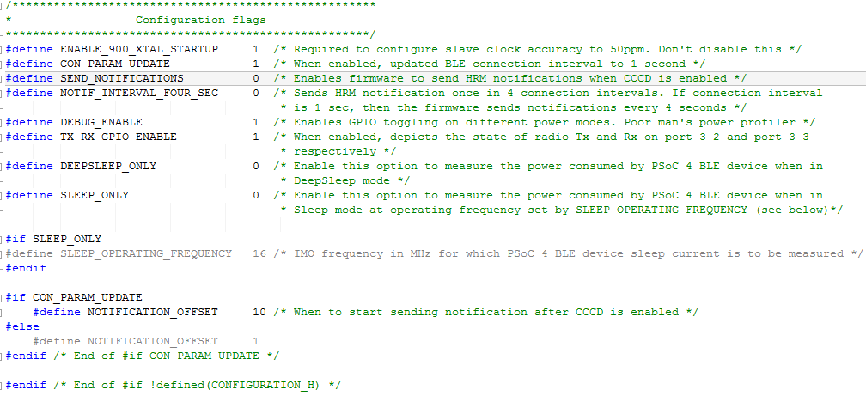

The firmware continuously advertises with an advertisement interval range of 20 to 30ms waiting for a BLE Central device to initiate a connection. Once connected, it maintains the BLE link with the Central device and waits for heart rate notifications to be enabled by the heart rate collector on the Central device. Once the heart rate notifications are enabled, depending on the firmware configuration flag settings, one or more of the following will happen:

* If CON_PARAM_UPDATE configuration flag is set, then the firmware sends a L2CAP connection parameter update procedure to the Central device requesting it to override the default BLE connection interval with a 1 second connection interval. This setting is useful to measure the idle mode current consumption for 1 second BLE connection interval.
* If SEND_NOTIFICATION flag is set, then the firmware sends one heart rate notification packet every connection interval so that current consumption of PSoC 4 BLE device while transferring non-zero payload could be measured.
* If NOTIF_INTERVAL_FOUR_SEC is set, once the heart rate notifications are enabled by the heart rate collector, the firmware sends one notification packet for four connection interval periods. This setting in conjunction with CON_PARAM_UPDATE flag enables you to measure 4 second data transfer power consumption of PSoC 4 BLE device.

Refer to [AN92584](http://www.cypress.com/go/an92584) for a list of tips and tricks for achieving low power consumption in PSoC 4 BLE and PRoC BLE devices.

## Build and Program

This section shows how to build the project and program the PSoC 4 BLE device on the BLE Pioneer Baseboard.

1. Open PSoC creator 3.1 SP1. Go to **File -> Open -> Project / Workspace**. Browse for the folder containing the project files and select **BLE_Power_Measurement.cyprj**.
2. Go to **Build -> Build BLE_Power_Measurement.**
3. On a successful build, the total flash and SRAM usage is reported as shown below
4. Select **Debug**> **Select Debug Target**, as shown below.



Selecting Debug Target

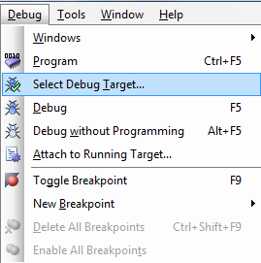

1. In the **Select Debug Target** dialog box, click **Port Acquire**, and then click **Connect** as shown below. Click **OK** to close the dialog box.

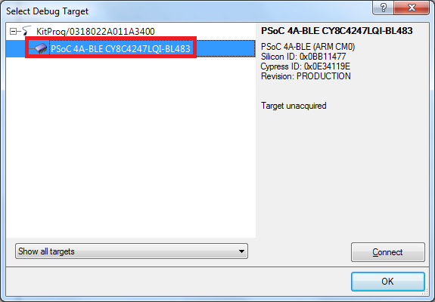

1. Select **Debug**> **Program** to program the device with the project, as shown below.

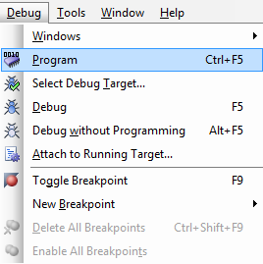

You can view the programming status on the PSoC Creator status bar (lower-left corner of the window), as shown below.



# 

# Current and debug plots

The following figure shows the PSoC 4 BLE device power plots and the state of Sleep and DeepSleep debug GPIOs (when DEBUG_ENABLE flag is set in firmware) during an active BLE connection interval.

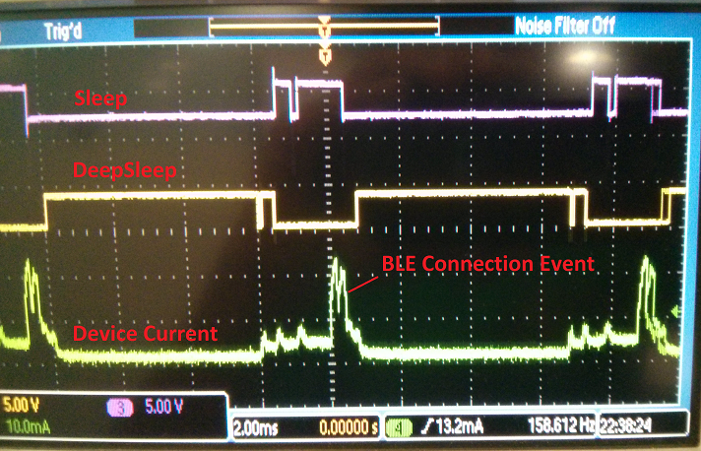

Similarly, if TX_RX_GPIO_ENABLE flag is set in firmware, the state of Tx_Enable and Rx_Enable debug GPIOs with respect to actual BLE RF event is as below:

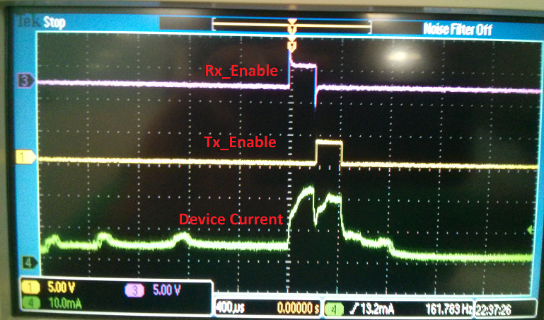

# Related Documents

The table below lists all relevant application notes, code examples, knowledge base articles, device datasheets, and Component / user module datasheets.

Related Documents

| Document | Title | Comment |
| --- | --- | --- |
| [AN91267](http://www.cypress.com/?rID=102504) | Getting Started with PSoC® 4 BLE | A guide for beginners on PSoC 4 BLE |
| [AN92584](http://www.cypress.com/go/an92584) | Designing for Low Power and Estimating Battery Life for BLE Applications | BLE low power application design guide |
| [001-90479](http://www.cypress.com/?rID=99492) | Programmable System-on-Chip (PSoC®) | PSoC® 4: PSoC 4XX7_BLE  Family Datasheet |